**Uchoa et al. – Dataset**

Three different positions for the depot are considered:

Central (C) { depot in the center of the grid, point (500,500).

Eccentric (E) { depot in the corner of the grid, point (0,0).

Random (R) { depot in a random point of the grid.

Three alternatives for customer positioning are considered, following the R, C and RC

instance classes of the Solomon set for the VRPTW [29].

**Random (R)** { All customers are positioned in random points of the grid.

**Random-Clustered (RC)** { Half of the customers are clustered by the above

described scheme, the remaining customers are randomly positioned.

**Clustered (C)** { At first, a number S of customers that will act as cluster seeds is picked from an uniform discrete distribution UD[3,8].

Next, the S seeds are randomly positioned in the grid.

The seeds will then attract, with an exponential decay, the other n-S customers : the probability for a point p in the grid to receive a customer is proportional to

$$\sum_{s=1}^{S}{e^{-d(p,s)/40}}$$

where: d(p; s) = distance between p and seed s

The divisor 40 in the above formula was chosen after a number of experiments.

**Acesso em:**

**VRP-REP: the vehicle routing problem repository**

[**http://www.vrp-rep.org/references/item/uchoa-et-al-2017.html**](http://www.vrp-rep.org/references/item/uchoa-et-al-2017.html)

**TRABALHO ORIGINAL.......onde foi proposto o Dataset.....2014**

E. Uchoa, D. Pecin, A. Pessoa, M. Poggi, A. Subramanian, and T. Vidal, “New benchmark instances for the capacitated vehicle routing problem,” Research Report Engenharia de Produção, Universidade Federal Fluminense, 2014. [View at Google Scholar](http://scholar.google.com/scholar_lookup?title=New+benchmark+instances+for+the+capacitated+vehicle+routing+problem&author=E.+Uchoa&author=D.+Pecin&author=A.+Pessoa&author=M.+Poggi&author=A.+Subramanian&author=T.+Vidal&publication_year=2014" \t "blank)

Não conseguimos este trabalho original. Apenas sua referência.

Esta informação foi obtida em outro paper (vide em PDF)

***Machine Learning-Based Parameter Tuned Genetic Algorithm for Energy Minimizing Vehicle Routing Problem***

<https://www.hindawi.com/journals/jie/2017/3019523/>

**TRABALHO PUBLICADO.......em 2017**

Uchoa, E. ; Pecin, D. ; Pessoa, A. ; Poggi, M. ; Vidal, T. ; Subramanian, A. (2017). New Benchmark Instances for the Capacitated Vehicle Routing Problem. European Journal of Operational Research, 257(3), 845-858.

**Este trabalho conseguimos cópia em PDF.**

<http://www.optimization-online.org/DB_FILE/2014/10/4597.pdf>

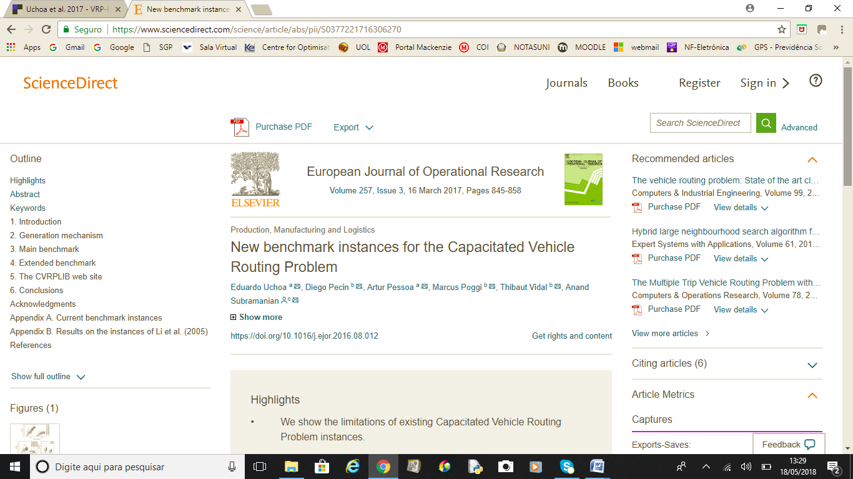

**Acesso em:**

**VRP-REP: the vehicle routing problem repository**

[**http://www.vrp-rep.org/references/item/uchoa-et-al-2017.html**](http://www.vrp-rep.org/references/item/uchoa-et-al-2017.html)

*VRP-REP is a collaborative open-data platform for sharing vehicle routing problem benchmark instances and solutions.*

VRP-REP é uma plataforma aberta de dados de compartilhamento de instâncias de problemas de roteirização de veículos, para utilização em *benchmarking* de soluções para este tipo de problema e similares.

